Software Requirements Specification
Team 4 – Mean Green Thumb

Sudip Khadka | Pete Maselli | Xavier Rosado
11591520 | 11808816 | 11678489

Professor Jiang Beilei
9.27.2026

Section 1: Revision History

Version | Date | Author | Description
1.0 | 09-26-2026 | Pete Maselli | Skeleton document
1.1 | 09-26-2026 | Sudip Khadka, Pete Maselli, Xavier Rosado | Initial draft

Section 2: Introduction
2.1 Purpose
This document is the Software Requirements Specification (SRS) for Mean Green Thumb, a web application that helps beginner gardeners choose plants, decide when to plant them, and care for them. It defines what the system shall do, including its functional and non-functional requirements, use cases, and operating environment, without specifying how it will be built.
This document serves as the common reference for the project. The development team will use it as the basis for design and implementation, testers will use it to verify the system against its requirements, and the course instructor will use it to evaluate the project.
2.2 Project Scope
Mean Green Thumb is a web application for the beginner gardener to get personalized gardening advice for their location. Users enter a zip code and receive guidance on what to plant, when to plant it, and how to protect their plants from bad weather.
The system will:
- Determine a user’s USDA plant hardiness zone from their zip code
- Retrieve local weather conditions from NOAA and generate severe weather alerts
- Recommend plants suited to the user’s location and the time of the year
- Generate a planting schedule based on frost dates and each plant’s needs
- Allow users to register, log in, and save their location to a profile
- Let registered users keep a personal “My Plants” list with care task checklists
- Let registered users share and read gardening tips from other registered users
Main benefits: Beginners get local, timely advice in one place instead of searching many sources, and they get reminders and alerts that help them avoid common mistakes.
Goals: help new gardeners choose suitable plants, plant at the right time, and keep their plants alive long enough to build their skills.
Out of scope for this release: a companion planting checker and sun exposure filtering are planned as future enhancements.

2.3 Problem Statement
Gardening isn’t easy. It can be extremely difficult to know where to start, and plants are not the most forgiving when it comes to mistakes. This can lead to would-be gardeners giving up before they really have a chance to learn the ropes. Mean Green Thumb will provide beginners with advice to make the transition from a greenhorn gardener to a proficient grower of plants, providing personalized suggestions for what to plant, when to plant, and weather-based alerts, all without having to scour the internet for hours on end. Our team chose this idea because we liked the available data that could be incorporated to provide something valuable, within the scope of our available resources.

2.4 Definitions and Acronyms
- SRS: Software Requirements Specification
- GUI: Graphical User Interface
- API: Application Programming Interface
- FR: Functional Requirement
- NFR: Non-Functional Requirement
- UC: Use Case
- MVP: Minimum Viable Product
- Growing Zone: A geographic classification (based on USDA hardiness zone data) indicating which plants are likely to thrive in a given area
- Frost Date: The average date of the last expected frost in spring or first expected frost in fall for a given location
- USDA: United States Department of Agriculture (source of Plant Hardiness Zone data)
- NOAA: National Oceanic and Atmospheric Administration (source of weather data)
- WCAG: Web Content Accessibility Guidelines

Section 3: Stakeholders
- Guest - A Guest is a visitor who hasn’t created an account yet. They can look up their growing zone, browse plant suggestions, and view weather forecasts before deciding whether to register. Their responsibilities are:
  - Registering for an account to unlock My Plants, Care checklists, Planting Calendar, Severe Weather Alerts, and Community features.
  - Providing an accurate zip code so the zone and weather data are correct.
  - Following the plant and weather guidance the system provides.

- Registered Users - Registered Users are Guests who create an account to unlock the full features. They save plants to My Plants, follow care checklists, generate planting calendars, and share tips with other registered users. Their responsibilities are:
  - Keeping their login credentials for the web app.
  - Posting appropriate, helpful tips in the community tips section.

- System Administrator - The System Administrator keeps Mean Green Thumb running smoothly after launch. They are responsible for:
  - Maintaining the database and running backups.
  - Managing access to the external weather and zone data sources.
  - Monitoring uptime during the demo period.

- Development Team - The Development Team (Sudip, Pete, Xavier) is responsible for the project’s life cycle from requirements to delivery. Their responsibilities are:
  - Outlining the project’s requirements.
  - Designing and implementing the features.
  - Testing the software all throughout the phases.
  - Dividing the work among team members and tracking progress.
  - Resolving issues that can delay the project.

- Third-Party Data Providers (USDA & NOAA) - The USDA will be providing the Plant Hardiness Zone data behind the zone lookup, and NOAA provides the weather data behind the forecasts and severe weather alerts. The system depends on both, so the team must keep up with any changes to their data formats or access. Their responsibilities are:
  - Keeping their data accurate and available for the web app.

Section 4: System Overview
4.1 Operating Environment
- Platform: Web application – can be accessed from Chrome, Firefox, Edge or Safari.
- Server-side: Python 3.12 with Flask as framework
- Database: SQLite – stores users, plants, saved plants, community tips and growing zones
- External Services: USDA Plant Hardiness Zone data to look up plant hardiness and NOAA weather data for forecasts/alerts. They both need Internet access at the server.
- Development Tools: VS Code, GitHub for version control and sharing, Lucidchart for diagrams, and Discord for Communication
- Clients Requirement: Browser and Internet connection
- Minimum hardware and software requirements: The server requires a 1-core processor, 1 GB of RAM (2 GB recommended), 1 GB of free storage, Python 3.12, and internet access to reach the USDA and NOAA data sources. Users need any desktop or mobile device with a current version of Chrome, Firefox, Edge, or Safari, JavaScript enabled, and an internet connection.
4.2 Assumptions and Dependencies
Assumptions:
- Users have internet access and a modern desktop or mobile browser
- Users provide an accurate location or zip code
- Users need no prior gardening experience or software experience
Dependencies:
- USDA Plant Hardiness Zone data stays available and accurate
- NOAA Weather data stays available for forecasts and alerts
- A backend database that stores accounts, saved plants and community tips

Section 5: Functional Requirements
FR-01: Zip code to Growing Zone Lookup
- Description: The system shall determine the user’s USDA plant hardiness zone from a 5-digit US zip code entered by the user and display the zone. If the zip code is not a valid 5-digit code, or does not correspond to a zone, the system shall display an error message and prompt the user to re-enter their zip code.
- Priority: High
- Assigned to: Sudip Khadka
FR-02: Plant Suggestion List
- Description: The system shall present a list of plants that can be grown in the user’s growing zone for a date selected by the user, defaulting to the current date. All suggestions shall contain the name of the plant along with a short description and recommended planting time. The user shall be able to search by plant name and sort the list by name or planting time.
- Priority: High
- Assigned to: Sudip Khadka
FR-03: User Registration and Log In
- Description: The system shall enable a new user to register a user name and password. The system shall permit a registered user to log in and log out of the system. The user’s zip code shall be saved in their profile and passwords shall be hashed before storing them.
- Priority: High
- Assigned to: Sudip Khadka
FR-04: Weather Integration
- Description: The system shall retrieve and display current and forecasted weather (temperature, precipitation) for the user’s location using NOAA data.
- Priority: High
- Assigned to: Xavier Rosado

FR-05: Severe Weather Alerts
- Description: The system shall notify users of freeze and frost warnings likely to affect their location.
- Priority: High
- Assigned to: Xavier Rosado

FR-06: Planting Calendar Generator
- Description: The system shall generate a personalized planting calendar for each saved plant that’s based on the user’s location and frost dates.
- Priority: Medium
- Assigned to: Xavier Rosado
FR-07: Community Tips and Sharing
- Description: The system shall allow registered users to post gardening tips and view tips shared by other registered users.
- Priority: Medium
- Assigned to: Pete Maselli

FR-08: Personal Garden List (“My Plants”)
- Description: The system shall allow registered users to save selected plants to a personal list so they can track what they are currently growing.
- Priority: High
- Assigned to: Pete Maselli

FR-09: Care Task Checklist
- Description: The system shall generate a checklist of care tasks (such as watering, checking for sprouts, and pest checks) tied to each plant a registered user has saved.
- Priority: Medium
- Assigned to: Pete Maselli

Section 6: Non-Functional Requirements
6.1 Performance Requirements
- The system shall return plant suggestion results within 3 seconds of a user submitting their zip code.
- The system shall support at least 50 concurrent users without noticeable slowdown.

6.2 Security Requirements
- The system shall hash all user passwords before storing them.
- The system shall log out users automatically after 30 minutes of inactivity.

6.3 Usability Requirements
- The system shall be usable on both desktop and mobile web browsers.
- The system shall follow basic WCAG accessibility guidelines (readable text contrast, alt text on images).

6.4 Reliability Requirements
- The system shall maintain 95% uptime during the semester demo period.
- The system shall back up its database daily.

Section 7: Use Case Diagram
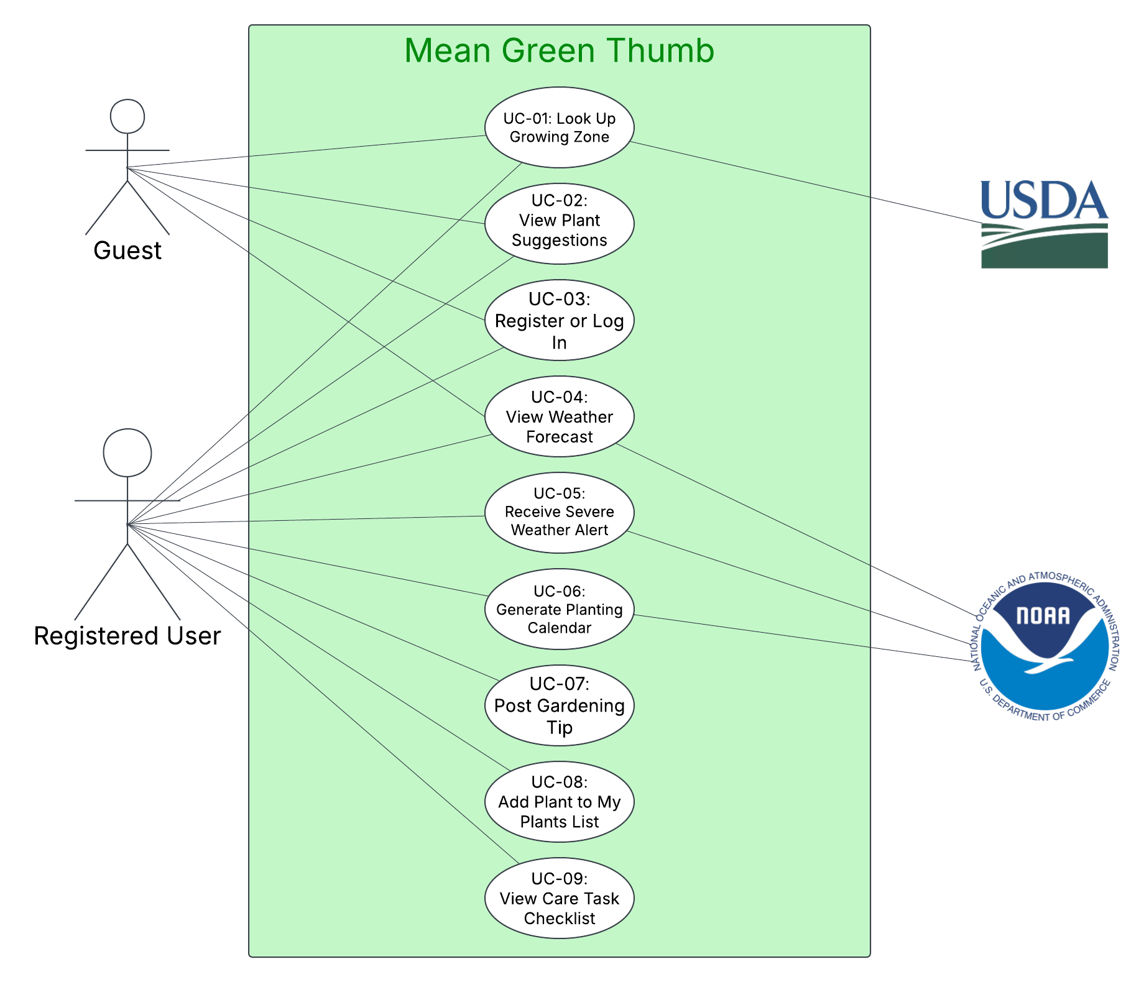

Section 8: Use Case Descriptions
UC-01: Look Up Growing Zone By Zip Code
- Author: Sudip Khadka
- Actor: Guest / Secondary Actor: USDA
- Description: A guest enters their zip code so the system can determine their USDA growing zone.
- Preconditions: The user has internet access and is on the Mean Green Thumb home page.
- Main Flow:
  - 1. User accesses the home page.
  - 2. System displays a zip code entry box.
  - 3. User inputs a 5-digit USA zip code and clicks "Submit”.
  - 4. System checks the zip code and retrieves the corresponding growing zone from the USDA data.
  - 5. System displays the growing zone and provides a link to see suggestions for plants.
- Alternative Flows:
  - 3a. If zip code is invalid, system displays an error message and prompts user to re-enter it.
  - 4a. If the zip code does not correspond to a zone, or zone data is unavailable, system displays an error message and prompts the user to re-enter the zip code or try again later.
- Postconditions: The user's growing zone is determined and suggestions for plants are available. If the user is logged in, their zip code is saved to their profile.

UC-02: View Plant Suggestions
- Author: Sudip Khadka
- Actor: Guest / Registered User
- Description: A user views a list of plants that can be planted in their growing zone on a given date.
- Preconditions: The user's growing zone has been determined (UC-01).
- Main Flow:
  - 1. User selects “View Plant Suggestions”.
  - 2. System displays a date selector, defaulting to the current date.
  - 3. User selects a different date or keeps the default date.
  - 4. System identifies plants suited to the user's growing zone for that date.
  - 5. System displays the list with each plant's name, short description, and recommended planting time.
  - 6. User may search the list by its default sort, plant name, or sort it by planting time.
  - 7. System updates the list accordingly.
- Alternative Flows:
  - 4a. If no plants match the growing zone and date, system displays a message suggesting the user choose another date.
  - 6a. If a search returns no matches, system displays a “no results found” message and leaves the search field intact.
- Postconditions: The user has seen plant suggestions based on their location and selected date. Registered users may add plants from the suggested list to My Plants (UC-08).

UC-03: Register or Log In
- Author: Sudip Khadka
- Actor: Guest / Registered User
- Description: A guest creates an account, or a returning user logs in, to access registered features such as My plants, care task checklists, planting calendars, and community tips.
- Preconditions: The user is not logged in.
- Main Flow:
  - 1. User selects "Register"
  - 2. System displays a registration form.
  - 3. User enters a user name, password and zip code, then clicks “Submit”.
  - 4. System validates the input, hashes the password, saves the zip code to the user’s profile, and creates the account.
  - 5. System logs the user in and displays their home page.
  - 6. On later visits, the user enters their user name and password to log in, and the system validates the credentials.
  - 7. When finished, the user selects “Log Out” and the system ends the session.
- Alternative Flows:
  - 4a. If a required field is blank, the zip code is invalid, or the password does not meet requirements, system displays an error message and does not create an account.
  - 4b. If the user name is already registered, system displays an error message and prompts the user to select a different user name or log in instead.
  - 6a. If the user name or password is incorrect, system displays an error message and does not log the user in.
- Postconditions: The user has an account and is logged in. The session terminates when the user logs out or after 30 minutes of inactivity.

UC-04: View Weather Forecast
- Author: Xavier Rosado
- Actor: Guest / Registered User / Secondary Actor: NOAA
- Description: User views current weather and forecast for their location.
- Preconditions: The user has a location or zip code set.
- Main Flow:
  - 1. User opens the weather dashboard.
  - 2. System retrieves current weather and forecast data from NOAA for the user’s location.
  - 3. System displays temperature, precipitation, and forecast.
- Alternative Flows:
  - 2a. If NOAA data is unavailable, the system shows the last cached forecast and flags it as outdated.
- Postconditions: User is informed of current and upcoming weather.
UC-05: Receive Severe Weather Alert
- Author: Xavier Rosado
- Actor: Registered User / Secondary Actor: NOAA
- Description: System will notify user of potential frost and freeze conditions that could harm their plants.
- Preconditions: User has created an account with a location set and notifications enabled.
- Main Flow:
  - 1. System shall report severe weather events for the user’s location, with information received from NOAA.
  - 2. System determines the event qualifies as an alert.
  - 3. System generates and sends the alert to the user.
  - 4. User views the alert details.
- Alternative Flows:
  - 2a. If no severe weather is reported, no alerts shall be generated.
- Postconditions: User is notified in time to protect their plants.
UC-06: Generate Planting Calendar
- Author: Xavier Rosado
- Actor: Registered User / Secondary Actor: NOAA
- Description: The User generates a personalized planting calendar for their saved plants.
- Preconditions: The User is logged in with at least one plant saved to their account.
- Main Flow:
  - 1. User opens the planting calendar.
  - 2. User requests a calendar to be generated.
  - 3. System calculates planting and care windows using the location frost dates for each saved plant.
  - 4. System displays the generated calendar to the user.
- Alternative Flows:
  - 3a. If frost-date data is unavailable for the location, the system shows general seasonal guidance instead.
- Postconditions: User has a calendar of planting dates for their saved plants.
UC-07: Post a Gardening Tip
- Author: Pete Maselli
- Actor: Registered User
- Description: A logged-in user shares a gardening tip with other users in their growing zone.
- Preconditions: The user is logged in.
- Main Flow:
  - 1. User navigates to the community tips section.
  - 2. System displays a form to submit a new tip.
  - 3. User enters their tip and submits it.
  - 4. System validates the input and saves the tip, tagged with the user's growing zone.
  - 5. System displays the tip in the community feed for that zone.
- Alternative Flows:
  - 3a. If the tip field is empty, system displays an error and does not submit.
- Postconditions: The tip is saved and visible to other users in the same growing zone.
UC-08: Add a Plant to My Plants List
- Author: Pete Maselli
- Actor: Registered User
- Description: A logged-in user saves a plant from the suggestion list to their personal garden list.
- Preconditions: The user is logged in and has viewed a plant suggestion list.
- Main Flow:
  - 1. User views a plant in their suggestion list.
  - 2. User selects “Add to My Plants.”
  - 3. System saves the plant to the user's personal list.
  - 4. System confirms the plant was added.
- Alternative Flows:
  - 2a. If the plant is already in the user's list, system notifies the user instead of duplicating the entry.
- Postconditions: The plant appears in the user's My Plants list.
UC-09: View Care Task Checklist
- Author: Pete Maselli
- Actor: Registered User
- Description: A logged-in user views the current care tasks for a plant they are growing.
- Preconditions: The user has at least one plant saved to My Plants.
- Main Flow:
  - 1. User opens a plant from their My Plants list.
  - 2. System displays the current checklist of care tasks for that plant, based on its planting date and timeline.
  - 3. User marks a task as complete.
  - 4. System updates the checklist and marks the task as done.
- Alternative Flows:
  - 3a. If a task is overdue, system highlights it as late instead of marking it complete.
- Postconditions: The checklist reflects the user's completed and outstanding care tasks.

Section 9: Individual Contributions
Name | Student ID | Contribution Summary
Sudip Khadka | 11591520 | Authored Section 2.1, 2.2, and 4.1 along with FR-01, FR-02, and FR-03 and their matching use cases UC-01, UC-02, and UC-03. Participated in final document assembly.
Pete Maselli | 11808816 | Authored Section 2.3, 2.4, and 6 along with FR-07, FR-08, and FR-09 and their matching use cases UC-07, UC-08, and UC-09. Built shared document skeleton. Participated in final document assembly.
Xavier Rosado | 11678489 | Authored Section 3, 4.2, and 7 along with FR-04, FR-05, and FR-06 and their matching use cases UC-04, UC-05, and UC-06. Participated in final document assembly.

